**Abstract**The domestic Dog derived from extinct Pleistocene wolves, having the modern wolf as the Dog's nearest living relative.

Robert Alberto

raalberto@adjuncts.pccc.edu

**The Dog**

Contents

Learning About Dogs 2

Examples of Dog breeds 2

Lifespan 2

Reproduction 2

Favorite Dog Breed 1

Works Cited 2

# Learning About Dogs

The Dog is a **domesticated** descendant of the **wolf**. The domestic Dog derived from extinct Pleistocene wolves, having the modern wolf as the Dog's nearest living relative. Dogs were the first species to be domesticated over 15,000 years ago before the development of agriculture. "Due to their long association with humans, Dogs have expanded to a large number of domestic individuals and gained the ability to **thrive on a starch-rich diet** that would be inadequate for other canids." (“Dog - Wikipedia”)

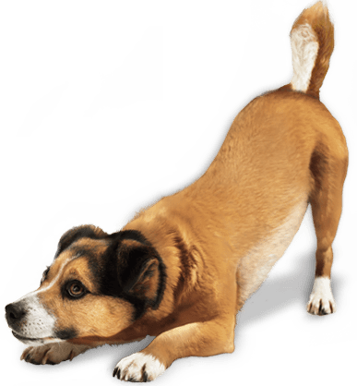

[This Photo](https://freepngimg.com/png/4592-dog-png-image) by Unknown Author licensed under [CC BY-NC](https://creativecommons.org/licenses/by-nc/3.0/)

The dog has been selectively bred over millennia for various behaviors, sensory capabilities, and physical attributes. Dog breeds vary widely in shape, size, and color. They perform roles for humans, such as hunting, herding, pulling loads, protection, aiding police and the military, companionship, therapy, and aiding disabled people. Over the millennia, dogs became uniquely adapted to human behavior, and the human–canine bond has been a topic of frequent study. This influence on human society has given them the sobriquet of "man's best friend".

## Examples of Dog breeds

* American Bulldog
* Beagle
* Chihuahua
* Dalmatian
* English Foxhound
* Labrador Retriever

### Lifespan

The typical lifespan of dogs varies widely among breeds, but for most, the median longevity (the age at which half the dogs in a population have died and half are still alive) ranges from 10 to 13 years. The median longevity of mixed-breed dogs, taken as an average of all sizes, is one or more years longer than that of purebred dogs when all breeds are averaged

### Reproduction

In domestic dogs, sexual maturity happens around six months to one year for both males and females, although this can be delayed until up to two years of age for some large breeds and is the time at which female dogs will have their first estrous cycle. They will experience subsequent estrous cycles semiannually, during which the body prepares for pregnancy.

|  |
| --- |
| B  I  O  L  O  G  Y |
| Anatomy | Description |
| Skeleton | All healthy dogs, regardless of their size and type, have an identical skeletal structure except for the number of bones in the tail, although there is significant skeletal variation between dogs of diverse types |
| Senses | A dog's senses include vision, hearing, smell, taste, touch. One study suggested that dogs can feel Earth's magnetic field |
| Coat | The coats of domestic dogs are of two varieties: "double" being familiar with dogs (as well as wolves) originating from colder climates, made up of a coarse guard hair and a soft down hair, or "single", with the topcoat only. |
| Tail | There are different shapes for dog tails: straight, straight up, sickle, curled, or corkscrew. |

### Favorite Dog Breed

#### History of the American bully

The American bully came about because of strategic and scientific crossbreeding in the mid-80s and 90s, serving as one of the first official U.S. created dog breeds. Dog breed types such as the American pit bull terrier and the American Staffordshire terrier were considered in this process, with the goal of making a family-friendly pup that would be loved for years to come.

#### American bully temperament and characteristics

American bullies don’t live up to their name, as they are one of the softest-tempered and sweetest dogs around! They are happy, sociable, and borderline boisterous, offering owners a bubbly and infectious personality like Old English bulldogs and Staffordshire bull terriers. "American bully: dog breed temperament and characteristics - Betterpet." <https://betterpet.com/american-bully/>.

# Works Cited

Levandowski, Christina. *American bully: dog breed temperament and characteristics*. 21 09 2023. <https://betterpet.com/american-bully/>.

Wikipedia. *dog*. 7 10 2023. <https://en.wikipedia.org/wiki/Dog>.